**Planetary Health Education (PHE) | Guide by SOPHEA project**

This document serves as a guide to design Planetary Health Education (PHE) sessions. PHE integrates aspects of the environmental, social and health crises into interdisciplinary teaching. It studies interactions between climate, environment, and health, requiring cross-discipline cooperation. Including PHE in curricula is crucial for achieving necessary transformative changes.

**Teaching Planetary Health by using blueprints**: A blueprint outlines the design of a training or workshop. It can vary in detail, ranging from a comprehensive guide to a generic structure, including key elements for sessions in Planetary Health. Blueprints serve as supportive documents to help you, as educators and multipliers, on your mission to spread PHE - please adapt them for your needs and contexts! We have created two blueprints for different purposes:

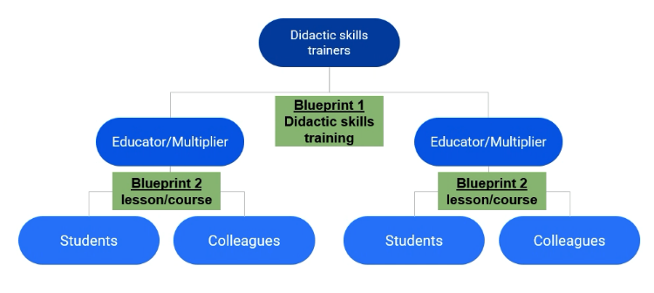**Blueprint 1 for didactic skills training (“Training of Trainers”)**: a comprehensive and detailed outline which is ready-to-use. The didactic skills training aims to equip *trainers* with essential facilitation techniques for implementing trainings and workshops in Planetary Health. It models the flipped-classroom approach and demonstrates a good-practice example of its use.

It can be implemented by **trainers** to promote the PHE toolbox and provide didactic skills training. Their primary target group are *educators/multipliers* (= active students, lecturers, health professionals, Planetary Health activists, … who have basic understanding and knowledge in the field of Planetary Health)

**Blueprint 2 for a PHE session**: a draft structure with an exemplary schedule for PHE sessions which can be tailored to specific target groups and content. It is adaptable for different session lengths and audience needs and can be applied for one or multiple sessions on different topics.

It can be implemented by **educators/multipliers** who use the content of the PHE toolbox in their trainings and workshops to disseminate different aspects of Planetary Health. Their target group can be fellow students, academic staff, community members, health professionals, local leaders, …

|  |
| --- |
| **Everyone can become a multiplier in Planetary Health Education!**  The field of Planetary Health is vast and multi-faceted which makes it impossible for a single trainer to comprehensively cover all relevant topics. With the increasing accessibility of knowledge in today's world, there is a wealth of information readily available. By compiling a toolbox which offers a variety of materials, contributed by experts from around the world, the SOPHEA project has created a structured overview of curated materials for PHE.  The "flipped classroom" approach describes the “outsourcing” of knowledge acquisition prior to a training or workshop session by using the materials from the PHE Toolbox. During the subsequent face-to-face sessions, in-depth reflection on the content and joint group discussions to explore possible applications are implemented. Consequently, educators and multipliers take on the role of facilitators, moderators, discussion leaders and coordinators of PHE interventions, rather than pure content experts. |

* Access the PHE Toolbox: <https://www.med.uni-wuerzburg.de/planetaregesundheit/ph-education-toolbox/>
* More information on the SOPHEA project: <https://www.med.uni-wuerzburg.de/planetaregesundheit/sophea-project/>
* For Questions and feedback please get in touch with the SOPHEA team: [planetaryhealth@ukw.de](mailto:planetaryhealth@ukw.de)

**Didactic skills training (“Training of Trainers”) for Planetary Health Education | Blueprint 1**

Below, you find the blueprint 1 for the didactic skills training using the SOPHEA online toolbox.

Suggested time frame: 1 session (120 minutes)

|  |
| --- |
| **Target group (16 - 20 participants)** |
| PHE educators & multipliers (= persons who will use the PHE toolbox to design and implement trainings and workshops in the field of Planetary Health) |
| **Learning objectives** |
| Participants…  **… are able to compose a training/workshop (by using a blueprint + integrating existing material from the PHE toolbox)**   * can explain the flipped-classroom approach and blended learning * can use the PHE Toolbox   **… are able to apply facilitation techniques with focus on motivation, reflection and transformation around Planetary Health in “live sessions”**   * formulate reflective questions for group work / breakout groups * engage with participants on their project ideas |

|  |
| --- |
| **Name of trainer(s):** |
|  |
| **Time and date for the training session:** |
|  |
| **Planning of time and logistics:** *When / how will the participants be informed? Will the training be online or face-to-face? Do you need to organize a room and material for the training (projector? Flipchart paper and marker?)* |
|  |

* **Preparatory task for didactic skills training** (will be shared by email with future multipliers beforehand | flipped classroom approach): **see document: “preparatory task”**

**Face-to-face session “Didactic skills training”**

|  |  |  |  |  |  |  |
| --- | --- | --- | --- | --- | --- | --- |
| **Time** | **Objectives** | **Format** | **Content/Method** | **Guiding questions (examples)** | **Material** | **Who?** |
| 20 min | Arriving | Plenary | Welcome & Introduction  Expectations | Round of introduction (poll)  Introductory question for a round of expectations: *“After this session, I would like to know… / have the following skills…”* | PPP, Mentimeter |  |
| 5 min | Activating prior knowledge | Plenary | **Input 1:** Key points flipped classroom / learning principles |  | PPP |  |
| 10 min | Repeating knowledge | Breakout groups 1  (4 persons per group) | Reflect on flipped classroom approach and use of PHE toolbox | * What is your impression of the flipped classroom approach? * Which materials did you select for a PHE session and why? |  |  |
| 5 min | Processing knowledge | Plenary | Feedback from breakout sessions | Zoom chat: “What I find useful in the flipped classroom approach” | Zoom Chat |  |
| 5 min | Refreshing | Pause | Stretching + Energizer |  |  |  |
| 10 min | Informing | Plenary | **Input 2:** Use of blueprint |  | PPP |  |
| 10 min | Storing knowledge + implementing | Breakout rooms 2  (4 persons per group) | Discuss on the use of blueprints and the integration of didactical aspects | * Have you ever worked with a blueprint before? In which context? * Which strengths do you see in using a blueprint for your next PHE session? |  |  |
| 10 min | Processing knowledge | Plenary | Feedback from breakout sessions | 1 person from each group gives 1-2 mins report from the breakout session |  |  |
| 10 min | Informing | Plenary | **Input 3:** Facilitation techniques for PHE |  | PPP |  |
| 10 min | Storing knowledge + implementing | Breakout rooms 3  (4 persons per group) | Reflect and share your experiences on own roles as educators/multipliers | * Which facilitation techniques do I find helpful? * How do I feel in my role as facilitator / motivator? * Where do I see my strengths as a multiplier? |  |  |
| 15 min | Evaluating | Plenary | Feedback from breakout sessions (Spotlight + Visualization); Way forward | Fill in the Whiteboard (1 sticky note / participant) | Zoom Whiteboard |  |
| 10 min | Closing + Feedback | Plenary | Oral feedback on the session  Farewell and Thank you ! | Share one aspect to keep, one aspect to improve. |  |  |