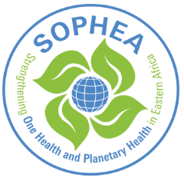
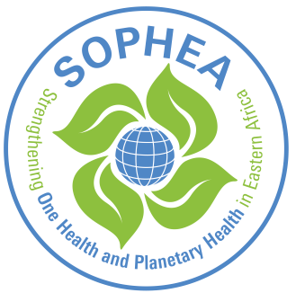
Planetary Health Education (PHE) | Didactic skills training
Preparatory task
Welcome to the didactic skills training for the realization of workshops on Planetary Health! We’re thrilled that you are ready to join us as a Planetary Health educator in this important endeavor! As an essential preparation for the ‘face to face’ session of this didactic skills training, please work carefully through all information on this page. This should take no longer than 45 minutes.
- We work with the PHE Toolbox, please register by using the following link:
https://www.med.uni-wuerzburg.de/planetaregesundheit/ph-education-toolbox/
Explore the PHE toolbox and discover chapters which resonate most with you or which have particular importance for your context. Identify three documents that you would like to include in your own PHE workshop (e.g. PowerPoint presentation, background resource, video, good practice example/case study). Download these materials and have them ready for the didactic skills training.

- We use a flipped classroom approach - what’s this?
- The flipped classroom approach reverses traditional teaching methods so that participants can study at their own pace prior to joint ‘face-to-face’ sessions.
- This study beforehand can include diverse resource materials (in the PHE Toolbox: PowerPoint presentations, videos, publications or case studies) which participants work through in advance to acquire a basic knowledge.
- The ‘face-to-face’ sessions (facilitated by educators or multipliers) are then dedicated to interactive activities (discussions and reflections) and the planning of joint actions.
- Blended learning (the combination of online learning and ‘face-to-face’ sessions) complements the flipped classroom approach, offering the possibility of easily integrating materials from global experts (e.g. recorded lectures or their shared PowerPoint Presentations), and “outsource” the step of knowledge acquisition. This also means that educators and multipliers don’t necessarily need to be content experts themselves.

For further insights into the flipped classroom and blended learning approach, please watch this video: https://www.youtube.com/watch?v=paQCE58334M

- Please read the following interactive & participatory teaching and learning principles to actively engage with participants in the educational process:
- Learning is an individual process, depending on multiple factors, like personal motivation, social interactions and environmental influences, among others.
  - Accommodate individual learning objectives and expectations and encourage peer collaboration in the group of participants.
- The emotional state and readiness of learners significantly impact the learning process.
  - Plan sufficient time for arriving and engaging the audience with the topic through interactive activities (round of introduction, telling anecdotes, showing a picture…).
- Adult learners bring diverse life experiences and prior knowledge, which influence learning.
  - Activate prior knowledge by incorporating real-life examples, case studies, or interactive exercises that encourage learners to draw upon their experiences.
- Balancing collective and individual learning phases promotes comprehensive learning.
  - Plan break-out sessions in groups for repetition, organization and application of knowledge and integrate individual reflection time. A blueprint (= structured design for a workshop or training session) can support you in ensuring a logical and efficient structure.
We will elaborate more on the above mentioned topics in our ‘face-to-face’ session. Thank you for taking the time to prepare; if you have any questions, please feel free to bring them for discussion & clarification.

